Lab Assignment 5: Sub queries and joins in University Database
Objective of this Assignment:
To write SQL query based on the concept of sub query and join.
A) Write the expression for the following set of queries in SQL, based on the set of schema
of Assignment (4), using concept of sub query.
1. Find out the names of instructors who work in the same department as the course_id is CS-101.
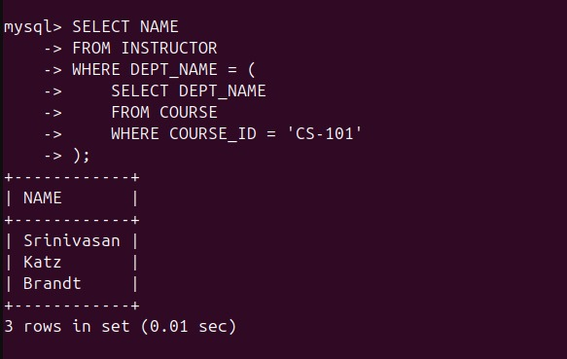
2. Find out the departments whose budget is higher than the budget of ‘Biology’ department.
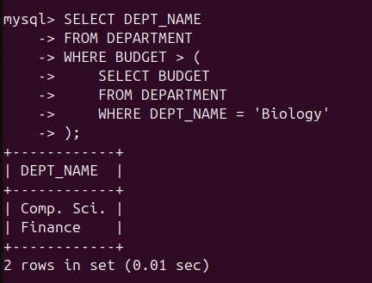
3. Find out the students who have taken a course in the same classroom where course_id is CS-101 is held.
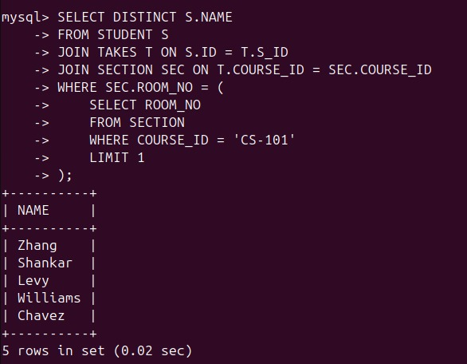
4. Find out the students who have taken all courses offered by 'Computer Science' department.
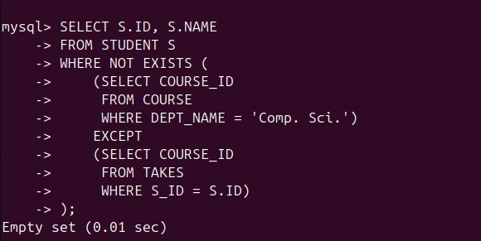
5. Find courses that are taught in a classroom located in the same building as room number 514.
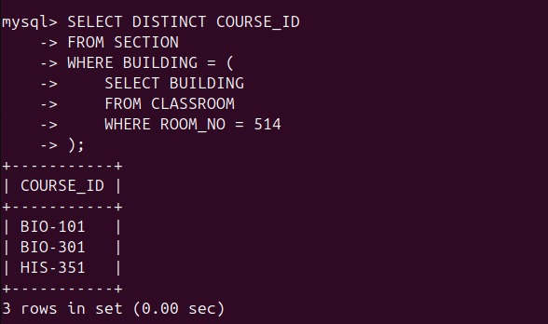
6. Find out the name of the instructor who has not taken semester as spring.
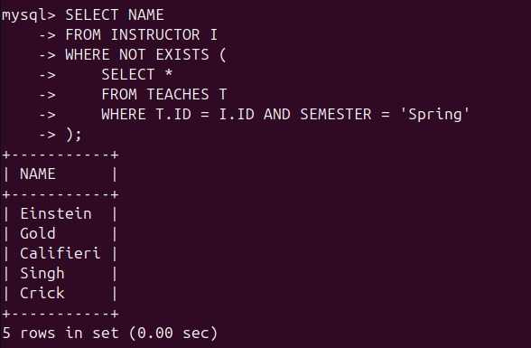
7. Find out the students who belongs to the department with the highest budget.
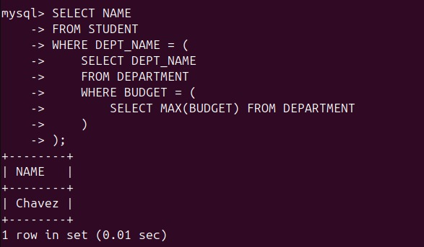
8. Find out the ID and name if the instructor who is the advisor of s_id is 44553.
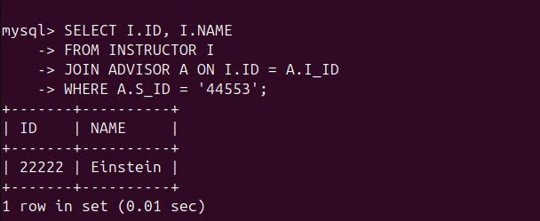
9. Find course_id and year for courses taken by “Srinivasan” in the fall semester.

10. Create a table named SEMESTER_TYPE from SECTION table with two columns named as SEMESTER and YEAR without taking any records from SECTION table.

11. Insert the semester and year from SECTION table into the SEMESTER_TYPE table who’s ROOM_NUMBER is less than 500.
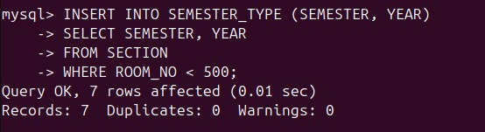
12. UPDTAE the semester to summer in SEMESTER_TYPE table for the course with course_id equal to CS-315.

13. Delete from SEMESTER_TYPE table the details of course whose room_number is greater than 1 0 1 .

14. Find out the ID, name that has greater tot_cred than some of the students belong to the Comp.sci. department. (Use >some clause)
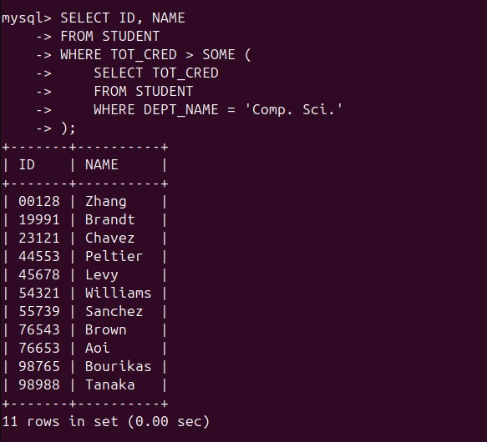
15. Find out the name that has greater tot_cred than all the students of Comp.sci. department. (Use >all clause)
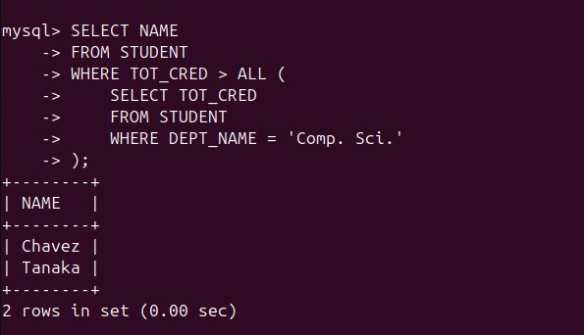
16. Display the details of the instructor where some classes are taken. (Use exist clause)
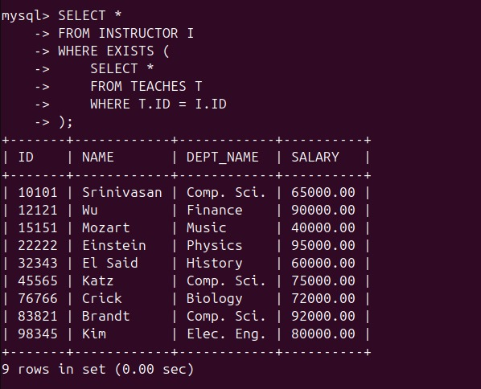
17. Display the details of the instructor for which no classes are taken. (Use not exist clause)
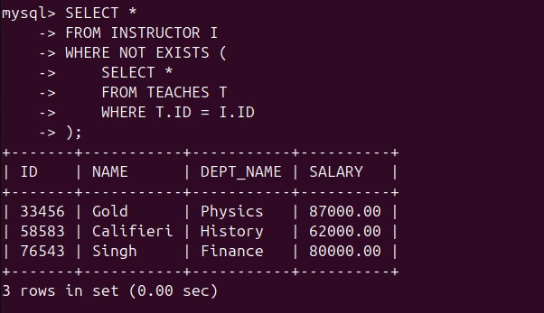
18. Increase all instructors’ salary with salary over 80000 by 8%, and all other instructors receive 6%. (Use case statement)
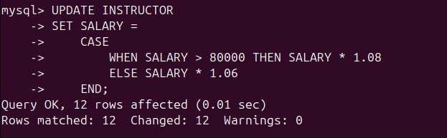
B) Write the expression for the following set of queries in SQL, based on the set of schema of Assignment (4), using concept of join.
1. Find out the name of the instructors who teaches any course in summer semester.

2. Find students who are enrolled in courses offered by the ‘Physics’ department.
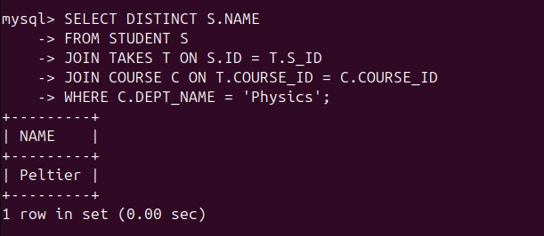
3. Find the building of the section in any course offered by BIOLOGY department.
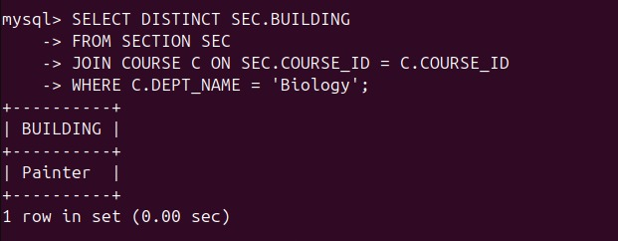
4. Find out the name and dept_name of student who taught by the instructor whose salary is more than 80000.
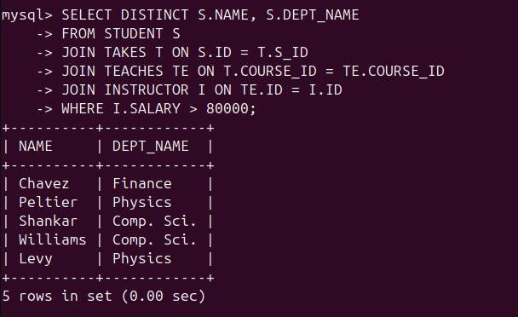
5. Find out the building and capacity of the classroom in the department of Comp.sci.
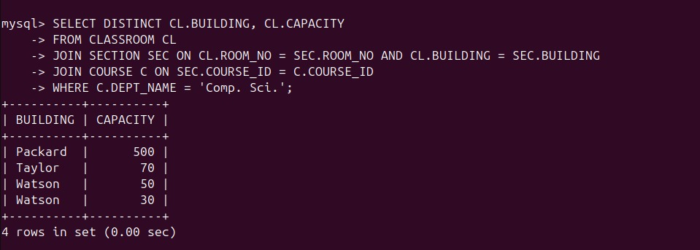
6. Find out the Name of the student whose building is not “Watson”.
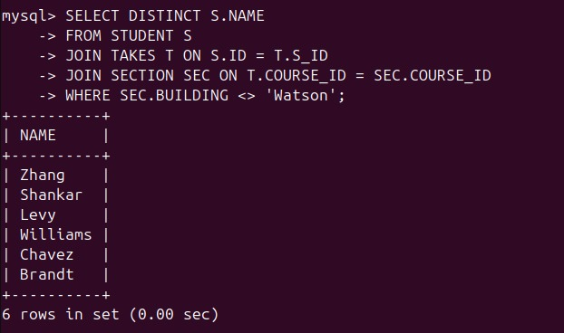
7. Find out the Name of the instructors whose classroom capacity is 500.
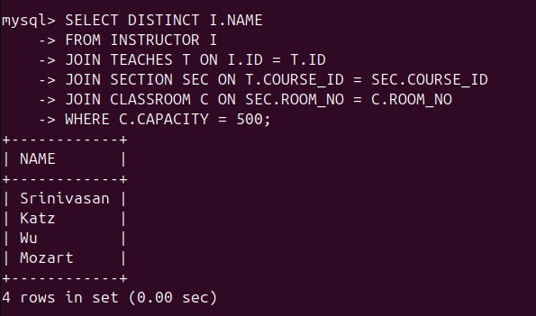
8. Find out the semester and grade of the student whose instructor name is Kim.
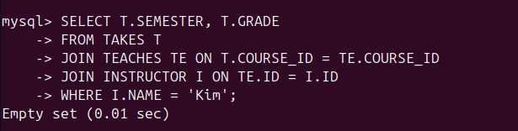
9. Find out the name and tot_cred of the students in the fall semester.
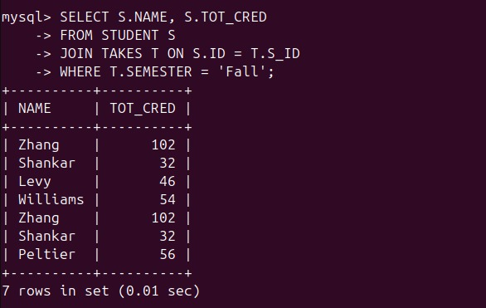
10. Find all dept_name where the total budget is greater than the average of the total budget at all departments. (Use with clause).
